**Connected and strongly connected components for clustering coefficient values 0.1, 0.2, 0.3 and 0.4 for Twitter dataset**

**number of components increase as we increase the clustering coefficient and reach max at 0.2 for strongly connected; and 0.3 for connected after which they start decreasing as the we increase the coefficient – (Please rephrase this in a better way for report…and also mention the reason why this is happening as explained by Chris )**

Clustering coefficient = 0.1

Connected components

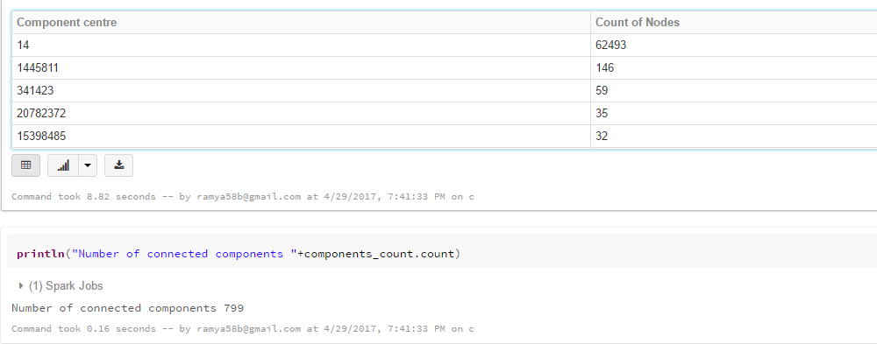

Strongly connected components

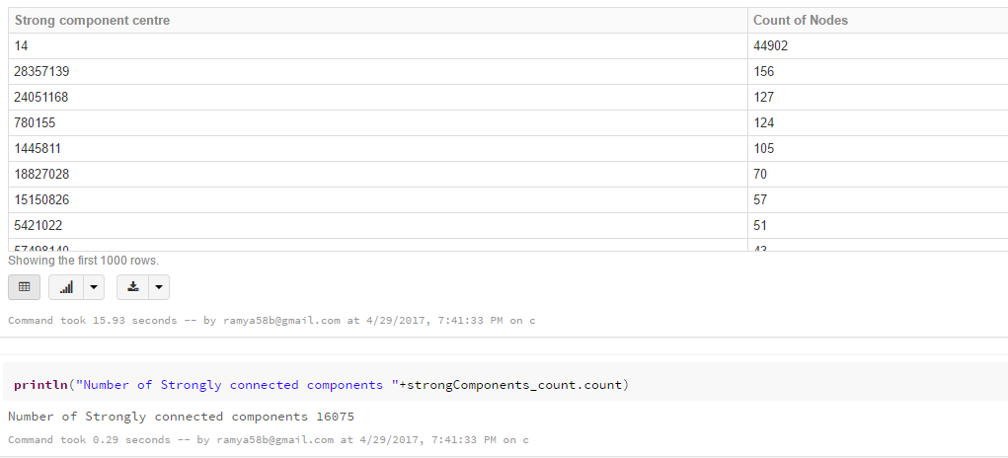

Clustering coefficient = 0.2

Connected components

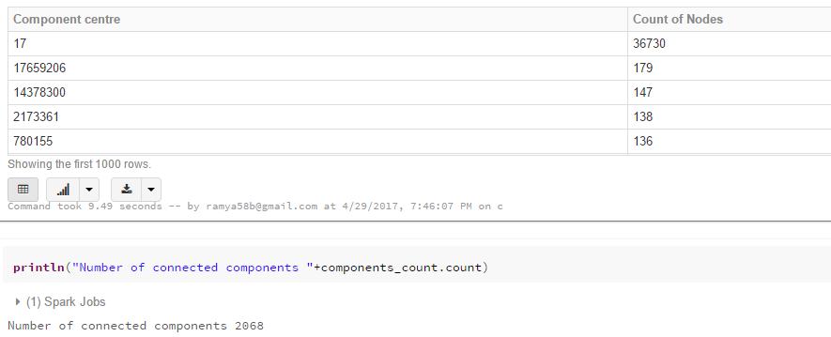

Strongly connected components

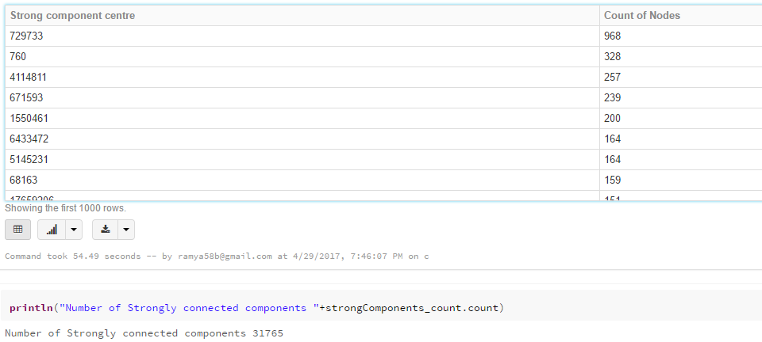

Clustering coefficient = 0.3

Connected components

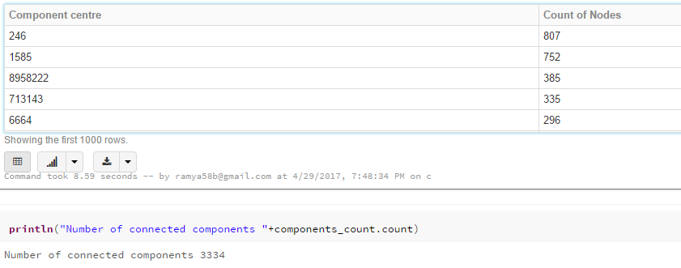

Strongly connected components

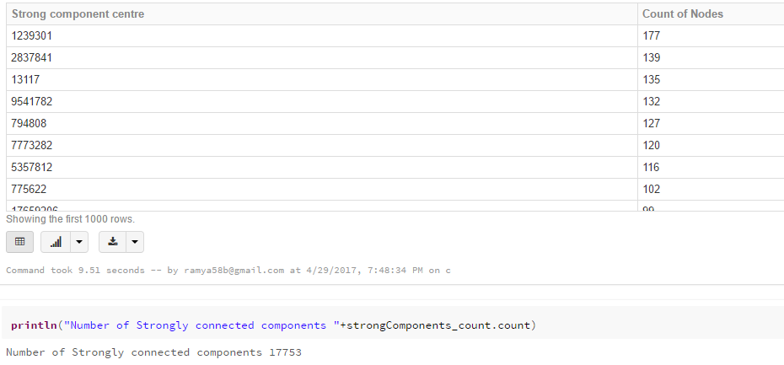

Clustering coefficient = 0.4

Connected components

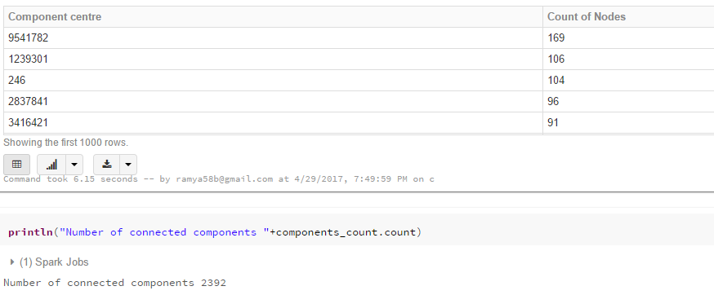

Strongly connected components

